**IMPORTANT RESOURCES**

* Genesis House 24 Hour Hotline Numbers:
  + (440) 244-1853
  + (440) 323-3400
  + Toll free 1-866-213-1188
* Web sites:
  + [www.genesishouseshelter.org](http://www.genesishouseshelter.org)
  + [www.facebook.com](http://www.facebook.com) (Genesis House Group)
  + [www.twitter.com](http://www.twitter.com) (GenesisHouse1)
  + Instagram : GenesisHouseShelter
* Other Important Numbers
  + National Teen Dating Abuse Helpline 1-866-331-9474
  + United Way First Call For Help “211”
  + 911 for emergency help
* **THINGS YOU CAN SAY TO A FRIEND WHO’S IN A VIOLENT RELATIONSHIP:**
  + You can’t change the abusive person
  + The violence WILL get worse
  + No one deserves to be abused
  + I’m sorry this is happening to you
  + I believe you
* **THINGS YOU CAN DO TO END DOMESTIC VIOLENCE**
  + Call out abusive behavior when you see it
  + Do not support people, music, movies, companies or products that contribute to a culture that supports violence against women
  + Believe victims
  + Hold abusers accountable

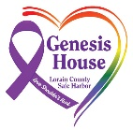

Healthy Dating

**Relationships**

I

RESPECT

YOU

U R KIND

YOU  
ARE  
MY   
EQUAL

U R

SMART

U R

SAFE

**A Guide helping teens develop healthy relationships and recognize unhealthy ones.**

**LOVE SHOULDN’T HURT!**

Genesis House

[www.genesishouseshelter.org](http://www.genesishouseshelter.org)

# The teen years are a time when lots of dating relationships will begin and end for everyone.

Most of these relationships will be fun and offer you the chance to experience new things and meet new people. They also will give you the opportunity to learn more about yourself.

Some of these relationships might not be healthy for you. This booklet will teach you the warning signs of dangerous relationships, so you will be able to spot them early and protect yourself from harm.

**What is Domestic Violence: A pattern of abusive and coercive behaviors, including physical, sexual, and psychological attacks, as well as economic coercion, that adults and teens use against their intimate partners. Also referred to as Intimate Partner Violence.**

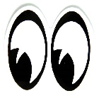**Abusers will often use abusive behaviors to control and show power over their dating partner. As teens, you are particularly at risk. Domestic violence in dating relationships is more likely to happen to young people, ages 16-24, than any other age group. The only other risk factor which increases a person’s likelihood of being abused by a dating partner, is being female.**

# DID YOU KNOW…

* 20% of children between the ages of 11 and 14 say their friends are victims of dating violence.
* 44% of all students have been in an abusive relationship by the time they graduate from college, 22% of all males and more than 50% of all females
* 86% of teens reported if abused they would sooner tell a friend over an adult.
* One women is abused every 15 seconds in the US by an intimate partner
* @ 3 women are murdered every day in the US by a husband or boyfriend
* 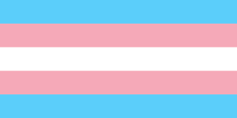C:\Users\Meg\AppData\Local\Microsoft\Windows\Temporary Internet Files\Content.IE5\E2UNSTUC\MC900391804[1].wmfDomestic violence occurs in LGBTQ+ relationships at similar rates as heterosexual relationships

**WHAT CAN I DO TO STOP**

[](https://www.bing.com/images/search?view=detailV2&ccid=RBp6uPYl&id=C55145AC7977E389267E35486AC10CEF139B2530&thid=OIP.RBp6uPYlj5JtLo7IadbXZwHaG9&mediaurl=http://www.clipartkid.com/images/719/pink-number-one-clip-art-at-clker-com-vector-clip-art-online-pxXuyY-clipart.png&exph=564&expw=600&q=1st+Clip+Art&simid=608038522840746548&selectedIndex=4)**DOMESTIC VIOLENCE IN MY COMMUNITY?**

**EDUCATE YOURSELF!** In order to truly know how to support survivors and have people listen to you, you have to know what you are talking about! Do your research. Talk to survivors, read books, listen to podcasts, watch movies and TED Talks. The more you educate yourself, the more credible you will be to others.

Check out:

Websites: www.genesishouseshelter.org

www loveisrespect.org

www.cdc.gov

TED Talks: Jackson Katz “Violence Against Women-It’s A Men’s Issue”

Leslie Morgan Steiner “Why DV Victims Don’t Leave”



**BE BRAVE!** Speaking out about any topic can be scary but domestic violence can really make people upset. Intimate Partner Violence is born from a belief system that makes people think they have the right to behave this way. So, telling someone that they don’t have the right to hurt or control others is offending their belief system, AND THEY DO NOT LIKE THAT! Be brave and be strong! Use facts and laws to support your arguments but always make sure you are safe.

If you have experienced abuse, please take care of yourself first. Talk to a professional and make sure you are emotionally ready to have tough conversations, so you don’t get triggered

[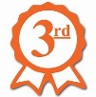](https://www.bing.com/images/search?view=detailV2&ccid=M6hmd2k2&id=1468E1C149DF117C5A795D62BBB658330E878221&thid=OIP.M6hmd2k2LWXsutMwSZLpoQHaHa&mediaurl=http://www.clipartkid.com/images/101/3rd-award-ribbon-clip-art-http-printablecolouringpages-co-uk-s-MgWXFH-clipart.png&exph=500&expw=500&q=3rd&simid=608028902082019580&selectedIndex=4&cbir=sbi)

**GET INVOLVED!** Join the *Genesis House Teen Street Team*, a well-trained group of teens from Lorain County working together to stop domestic violence and teen dating violence. We conduct educational programs, awareness campaigns and support for survivors in schools and the community. The TST works to change the environment of a school to make domestic violence unacceptable and make survivors feels supported and safe.

**BLAMES OTHERS FOR THEIR BEHAVIORS:** Do you feel you often have to apologize for things you don’t really think you did wrong? Abusers are people who don’t take responsibility for their behavior. Everything’s always someone else’s fault. An abuser will blame you for every argument, whether you did anything wrong at all. They will say things like, “I wouldn’t of had to tell you to shut up if you hadn’t been running your mouth.”

**BLAMES OTHERS FOR THEIR FEELINGS:** Does your partner tell you “You make me mad”, “You’re hurting me by not doing what I want you to do”, “You make me yell/hit you”, and “I can’t help but be angry”? In reality the abuser is really making the decision about what they think or feel but will use feelings to manipulate their partner. What they are doing is trying to make their abusive behavior your fault.

**QUICK INVOLVEMENT:** Has this relationship moved much faster than you are comfortable with? Often an abuser will pressure you or guilt you into moving the relationship along very quickly. Remember that it’s always o.k. for you to slow things down. Don’t let someone pressure you into anything you aren’t comfortable with. Healthy relationships are a 50/50 deal, everyone gets an equal share of the say and space in your relationship.

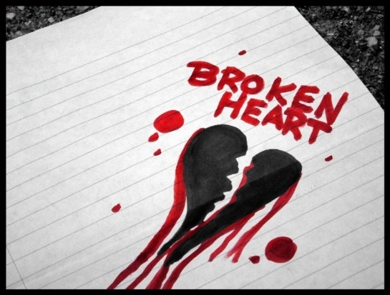**USE OF FORCE DURING AN ARGUMENT:** Has your partner ever physically restrained you from leaving a room?Or has your partner ever broken something you love or thrown something during an argument? Any use of force, threat of force, throwing or breaking objects is a sign of extreme emotional immaturity and danger. Next time that object may be you.

**Safe Dating Habits**

**Always be assertive:** Be firm and straightforward in your relationships. Sometimes telling people what you want and how you feel can be uncomfortable, but it’s necessary.

**Trust is important:** Each person needs to trust the other for a relationship to be healthy.

**Space and privacy are your RIGHT:** Being able to spend time away from your partner is one of the marks of a healthy relationship. You have a right to space and privacy. Both people should have their own friends and hobbies. Everyone has the right to keep certain aspects of their lives private, including passwords.

**Thoughts can be expressed openly:** You should always feel safe to express your thoughts and needs to your partner, even if it means refusing to give them something they want.

**Things aren’t rushed:** Both people in the relationship need to be comfortable with how things are moving along. You should know your partner well before you commit to them.

**Use social media cautiously:** Keep in mind that everything you post online is stored on a remote server and cannot ever be fully deleted. Sexually explicit images that are shared or stored online can always be traced back to you. Never share anything online that you wouldn’t want your family and/or entire school to see.

**Get their consent:** Keep yourself and you partner safe by making sure any physical contact you have is consensual. A person who is under the influence of drugs or alcohol can never give consent.

**Trust your instincts:** If a situation makes you feel uncomfortable, try to be calm and think of a way to remove yourself. Trust your gut!

**DATING BILL OF RIGHTS**

|  |  |
| --- | --- |
| **I have a right to:**   * Ask for a date * Refuse a date * Suggest activities * Refuse any activities, even if my date is excited about them * Have my own feelings and be able to express them * Say, “I think my friend is wrong and their actions are inappropriate” * Tell someone not to interrupt me * Have my limits and values respected * Tell my partner when I need affection * Refuse affection * Be heard * Refuse to lend money * Refuse sex any time, for any reason * Have friends and space aside from my partner * Privacy | **I have the responsibility to:**   * Determine my limits and values * Respect the limits of others * Communicate clearly and honestly * Not violate the limits of others * Ask for help when I need it * Be considerate * Check my actions and decisions to determine whether they are good or bad for me * Set high goals for myself     **I will use my voice and stand up for myself!**  From the Domestic Violence Advocacy Program of Family Resources, Inc. |

**CHECK OUT YOUR RELATIONSHIP FOR RED-FLAGS OF ABUSE!**

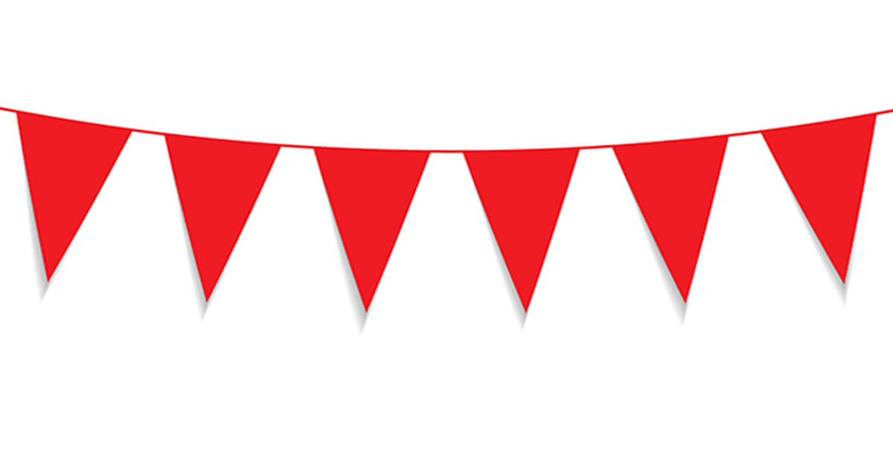A “Red Flag” is a something your partner does that should make you pause, and wonder is this relationship is right for you. If any of these behaviors are present in your relationship, you need to ask yourself, “am I safe?”

**ISOLATION:** Do you have fewer friends now than you did before? One of the first things an abuser does is get rid of all your friends and family. It’s a lot easier for your abuser to control you if there’s no one else in your life to witness their treatment of you.

**CONTROL**: Do you HAVE to answer when your partner calls or immediately text back, or they will get mad? Do they question where you have been and who you have been with? Do they tell you what you can and cannot wear? Do they tell you where you can and cannot go? Are they trying to make personal decisions for you? Are they checking to see who you are talking and reading your text messages? This behavior is not o.k., and it’s a big red flag that there is something wrong with your relationship.

[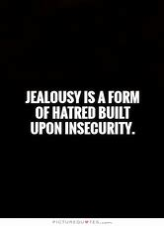](https://www.bing.com/images/search?view=detailV2&ccid=8FoIqYT0&id=35A86B01FD2E211E39B32AE1A588CD00E4A7BD7E&thid=OIP.8FoIqYT0MtkeFHNrPb2eLQHaKI&mediaurl=https://www.askideas.com/media/80/Jealousy-Is-A-Form-Of-Hatred-Built-Upon-Insecurity.1.jpg&exph=684&expw=500&q=jealousy&simid=608041297390864253&selectedIndex=3&cbir=sbi) **JEALOUSY:** Are you often accused of flirting or cheating? Are they creeping all over your social media to find examples of you cheating? Have your grades dropped significantly?When you are in an abusive relationship, your abuser wants you to spend every second with him/her. You might not even realize at first that you are neglecting things you used to spend a lot of time on, like school, work, sports, extracurricular activities and friends.

**THE 5 KINDS OF ABUSE:**

PHYSICAL ABUSE

Shoving Hitting Slapping Grabbing

Holding you down Strangulation Pulling hair

Burning Blocking you from leaving

Poking Squeezing

|  |  |
| --- | --- |
|  |  |
| **EMOTIONAL ABUSE**  Putting you down Belittling your accomplishments  Keeping you from friends or family | Following you  Telling people bad things about you  Texts you non-stop |
| Sexual abuse  Forcing you to do things you aren’t comfortable with  Not letting you use birth control | Giving you an STD  Constantly accusing you of cheating  Asking for sexual/naked pictures of yourself |
|  |  |
| Financial abuse  Taking your money Destroying your things Not letting you work or go to school | Always making you pay  Making you account for every penny you spend |

PHYSICAL ABUSE

Shoving Hitting Slapping Grabbing

Holding you down Strangulation Pulling Hair

Burning Blocking you from leaving

Poking Squeezing

VERBAL ABUSE

Calling you names Swearing at you Yelling Screaming Threatening you Embarrassing you Calling you crazy (or ugly, stupid, etc.) Threatening to “OUT” you

SEXUAL ABUSE

Forcing you to do things you aren’t comfortable with Not letting you use birth control Giving you a STI Cheating/ accusing you of cheating

Asking for naked pics of you

EMOTIONAL ABUSE

Putting you down Embarrassing you publicly

Stalking you Making fun of things that matter to you

Keeping you from friends and family

Texting you non-stop

Threatens to kill themselves if you break up with them

FINANCIAL ABUSE

Taking your money Destroying your things

Always making you pay Not letting you work

Not letting you go to school

Making you account for every penny

**CYCLE OF VIOLENCE!**

**Honeymoon**: Every relationship starts in the Honeymoon phase. This is when people are on their best behavior and you are getting to know the best of a person. Eventually, you start to get comfortable and you commit to the relationship.

**Tension Building**: Every relationship has disagreements. In healthy relationships, when disagreements happen, you both use healthy communication skills, and everyone feels heard and respected. In unhealthy relationships, one person dominates the disagreement and the other feels ignored, small and/or scared.

**Acute Explosion**: Any type of abuse occurs.

**Honeymoon:** Abuser may apologize for abuse, promise it won’t happen again, will go and get help, deny the abuse was their fault, act like it didn’t happen, blames victim for the abuse or give gifts. Victims may hope abuse is over and trust that abuser is sorry.

Once the abuser is comfortable that the victim isn’t going to leave, the Tension Building phase starts all over again.

**SAFETY PLANNING**

**For teens in a violent relationship**

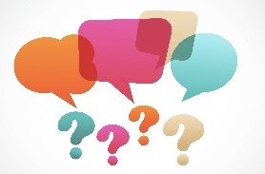If you are in a violent relationship, you should start planning for how to get safe. Here are some questions to ask yourself when creating your own safety plan:

* Which adults can I tell about the abuse?
* Who can I tell at school so that I can stay safe while I’m there? (teachers, principal, security guards, counselors)
* Who can I call for a ride if I need to leave a situation fast?
* Where are the local police departments in my neighborhood?
* How can I change my route to and from school, and how can I change my routine in general so that it’s difficult to follow me?
* Do I need to change my cell phone number? How do I block numbers?
* Does my abusive partner have passwords to my cell, social media, email and/or my locker combination? If so, how can I change those things?
* Can I make a code word with my friends or family that I could say or text that would indicate to them that I’m in trouble and I need their help?
* Am I eligible for a protection order, or can I press criminal charges against my abusive partner?
* Which friends can I walk home with, or walk to class with? How can I make sure I’m alone as little as possible?
* Which friends can I tell that would be helpful and wouldn’t treat this as gossip and spread it around?
* What other things can I do? _________________________________________________

____________________________________________________________________________________________________________________________________________________________________

**HISTORY OF ABUSE:** Have you found out that your partner experienced violence at home?Most abusers come from homes where violence has happened. Boys who have experienced violence at home are 1,000 times more likely than other boys to be violent in their own relationships. Have they been in a past abusive relationship as the abuser? If you have heard that they have abused a former partner, then most likely, they will be abusive to you.

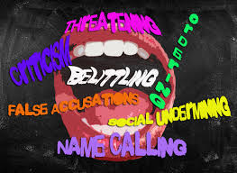**VERBAL ABUSE:** Has your partner called you names or put you down, and then said it was just a joke or were “just playin?” Hurtful behavior isn’t funny—ever. Calling you names and putting you down IS abuse.

**FEAR:** Does your partner’s behavior scare you sometimes?If your partner punches walls or throws things when they’re angry, they might become violent with you sometime. You should never fear the person you are dating.

**RIGID SEX ROLES:** Does he believe that women are to act one way and men are to act another?Does he make sexist jokes or comments about women? Abusive men see women as inferior, responsible for basic tasks, holding less power in the relationship. Are there 2 different sets of rules in your relationship? Abusive men do not see women as equals to men.

\**Healthy relationships are based on equality. There should never be 2 sets of rules! What’s good for your partner should be good for you.*